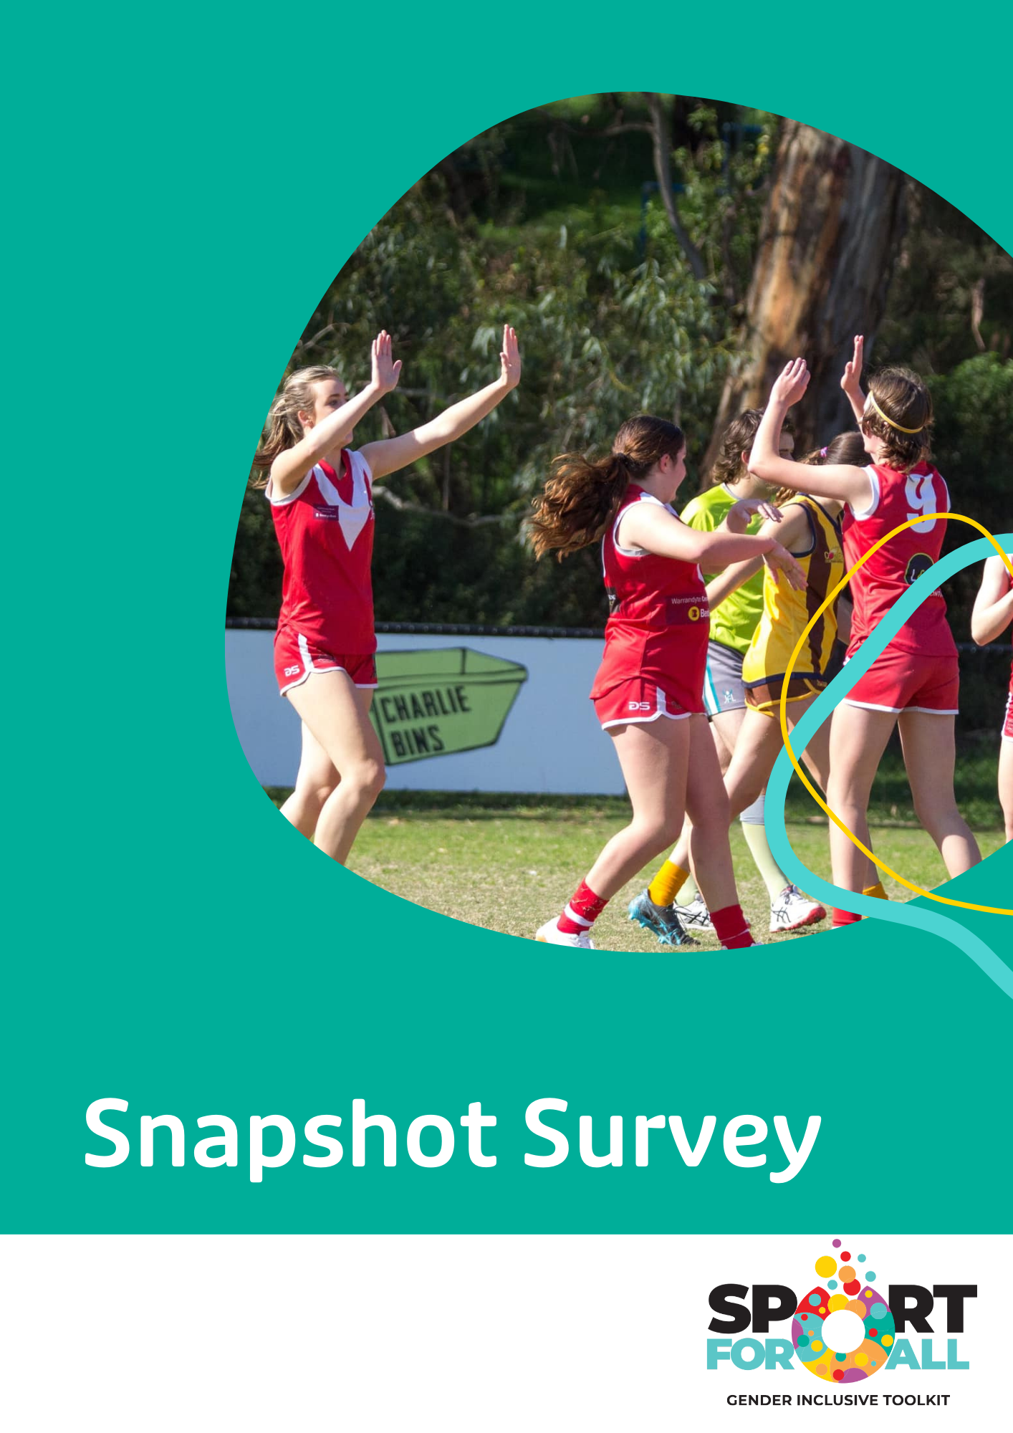

**Sport for All Snapshot Survey** 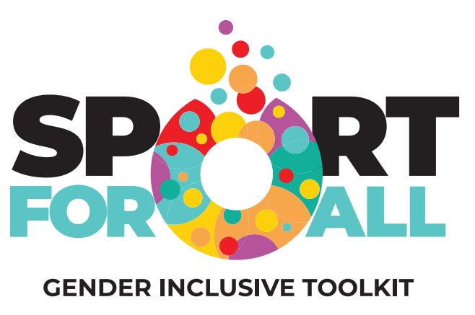

Thank you for completing the Sport for All Snapshot Survey. This survey forms part of the broader Gender Inclusive Toolkit initiative that your club/setting has engaged in.

This 5-minute survey is aimed at understanding the insights and experiences of club members, players, parents, volunteers and committee members regarding gender equity and inclusion at your club or setting. Your responses are anonymous. Honest feedback is encouraged.

Disclaimer:

The language used in the toolkit, resources and surveys refers to various gender identities including women and girls, men and boys, transgender, and gender diverse individuals. It is not the intention to encourage clubs and settings to make assumptions about gender identities or to “out” individuals who may identify as trans or gender diverse. Our goal is to promote inclusivity and respect for all, regardless of gender identity or expression.

|  |  |  |
| --- | --- | --- |
| **1** | What is your age | Choose an item. |
| **2** | What is your gender? | Choose an item. |
| **3** | Are women and girls, transgender and/or gender diverse people represented across all levels of your club or active recreation setting e.g. playing, volunteering, leadership, spectators.  Click or tap here to enter text. | Choose an item. |
| **4** | Does your club *call out* and take action against derogatory or stereotyped comments or sexist language, e.g. ‘you’re playing like girls’, ‘you should be home cooking.’  Click or tap here to enter text. | Choose an item. |
|  | Do you see people of all genders given the same opportunities across all levels of your club, e.g. playing, coaching, umpiring, leadership, infrastructure (change rooms, toilets, equipment), scheduling (allocation of grounds).  Click or tap here to enter text. | Choose an item. |
| **6** | Please add a comment if you would like to share more information  Click or tap here to enter text. |  |